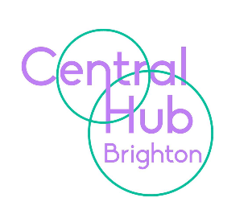

22 October 2021

Dear Parents/Carers and Students
This will be my last letter to you as I am leaving Central Hub Brighton after half term. I have worked here for almost 10 years - first as head of The Connected Hub, and then for the last 3 years as Executive Head, but I feel that it is now the time to step away and take on something new.
It has been a wonderful role, working with our amazing young people and I have been privileged to lead a great team. I know that the staff will continue to care for your children, have high expectations of and for them, and I wish them all healthy and happy lives.
Kindest regards

Louise

